Awards Tool Guide

what is the awards tool?
The Awards tool can be used to create Badges and Certificates to reflect the achievement of different milestones within a course offering. In the Awards tool, instructors can design badges and certificates and link them to release conditions to allow automatic awarding. Learners can see the awards that they have already earned, as well as those that they have yet to earn, in the associated My Awards tool.
Learners can let others know what they have earned by sharing their awards to their learner profile or to social media via Mozilla® Backpack.

why use the awards tool?
Use the Awards tool to:
- Reward learners with badges and certificates immediately after they have completed an activity or assignment.
- Build an element of gamification into your course and better engage your learners.
- Provide a consolidation/ celebration piece to the completion of an assignment or activity.
- Track learner progress and development.
- Build a hands-off method of instant feedback.
- Provide learners with certificates that they can share through social media.

user story
Dr. Aristova teaches a course on Russian Literature. She wants to provide badges to her students each time they complete one of the four course modules successfully, as well as one certificate that is awarded once all four modules are finished. She creates the four badge awards and attaches each to a release condition that requires a 75% or higher achieved on its appropriate quiz. She also creates a certificate award that is released when all four quizzes have been completed.
Bruce Medway is a student in Dr. Aristova’s class. He likes that he can track his achievement in the course and see which Badges he still has left to earn, something that helps to motivate his learning. He also is excited to share his course certificate outside of the Learning Environment using Mozilla® Backpack.

creating awards
Badges and certificates are created using the Awards tool, which can be accessed through your course navbar. You can view shared awards and then select Add Award to Course, or you can select Create Award to build from scratch. Add a name and description, and select the Award Type (badge or certificate).
Expiry Dates can be set as relative or fixed dates. You can also choose to share your award with other courses or to limit it to the current org unit and its child org units. The Issuer Information is displayed when the award is shared outside of the Learning Environment.

award images
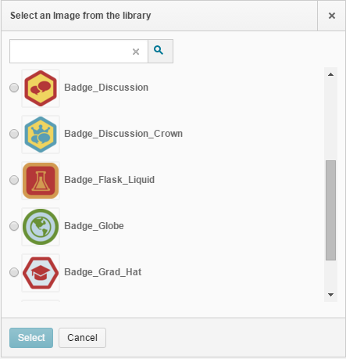
The award icon image can be selected from the existing images in the Award Icon Library, uploaded from your computer, or created using Badge Designer. To use Badge Designer, click on Create your own award image.

award icon library
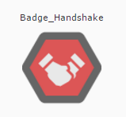
In the Award Icon Library page, you can upload and manage existing award icons. Icons added here will be accessible when creating future awards.

awards and release conditions
Once your award has been created, you can associate it with release conditions and credits by selecting Edit Properties on the Course Awards page. See the Release Conditions Guide for more information on release conditions. Once associated with release conditions, the award will automatically be awarded to all learners who achieve that condition, including those who completed the condition in the past.
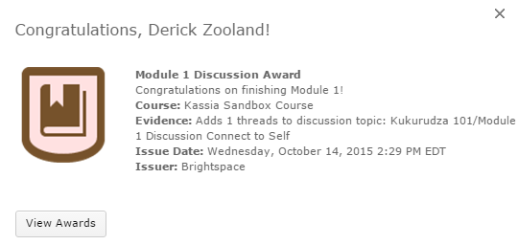
Learners will see a notification with an image of their award pop up on the screen, and then can access their award through the My Awards tool. Learners can also be notified by email or a notification.

my awards
The My Awards tool can be accessed by learners and used to view their achieved awards and available awards. Learners can also view the details of their achieved awards and print or share their awards to their learner profile, Mozilla® Backpack or an email address. Administrators must have allowed this sharing first through the Permissions tool.

classlist awards
On the Classlist Awards page, instructors can see a list of their class participants along with the awards they have currently achieved. The filter bar at the top allows you to search by sections or by badges only/ certificates only. You can also manually assign users awards or revoke existing users’ awards.

effective practices
- Ensure that learners have access to the My Awards tool in the course navbar so that they can access their badges and certificates
- When using release conditions, make sure not to create circular or impossible-to-achieve conditions. See the Release Conditions Guide for more information.

what tools interact with awards
Many tools interact with the Awards tool. Some common interactions are:

want more informatioN?
Visit the Brightspace Community (https://community.brightspace.com) or D2L Resource Centre (https://documentation.desire2learn.com) for videos, documents and other resources.
About D2L

A global leader in EdTech, D2L is the creator of Brightspace, the world’s first integrated learning platform. The company partners with thought-leading organizations to improve learning through data-driven technology that helps deliver a personalized experience to every learner, regardless of geography or ability. D2L’s open and extensible platform is used by more than 1,100 clients and 13 million individual learners in higher education, K–12, healthcare, government, and the enterprise sector—including Fortune 1000 companies.
The company has operations in the United States, Canada, Europe, Australia, Brazil, and Singapore.
© 2014 D2L Corporation.
The D2L family of companies includes D2L Corporation, D2L Ltd, D2L Australia Pty Ltd, D2L Europe Ltd, D2L Asia Pte Ltd, and D2L Brasil Soluções de Tecnologia para Educação Ltda.
Brightspace, D2L, and other marks (“D2L marks”) are trademarks of D2L Corporation, registered in the U.S. and other countries. Please visit D2L.com/trademarks for a list of other D2L marks.

